

King Khalid University,
Department of Information Systems, Applied College, Mahayil Asir

Diploma Programme in Information Systems

Applied Project
" Project Title "
Submitted By:
Student ID | Student Name

Supervised By: Dr. Khalid Mahmood Ali Asghar
---------------------------------------------------------------------

ABSTRACT

This system " Medical Records via ID " will provide a unified platform to the patients' medical history across all the hospitals in Asir province. The proposed system is characterized by precise content and easy access through ID by a doctor, patient, or pharmacist, and people who can help the patient in times of emergency, where records are linked among different departments of the hospital. The MRID system will save the time and effort through the management of all medical records within one program. This comes because of the continuous technological improvements and developments, which enrich our society with tools and programs that simplify our lives and make it as easy as possible.

ACKNOWLEDGMENT

We want to thank everyone who making it possible for students like us. And we would like to express our deepest gratitude to "Allah" firstly,
and then to Dr. Khalid Mahmoud, our project supervisor, for his invaluable advices, guidance and his enormous patience throughout the development of the research, and useful critiques of this research work.
We would like to express our gratitude towards our parents for their kind cooperation and encouragement which helped us in finishing this project. And a special thanks to everyone with whom we have reached this stage, especially the faculty members in the college whom we met during our studies.

COMMITTEE REPORT

We certify that we read this graduation project report as examining committee, examined the students’ project in its content and that in our opinion it is adequate as a report document for Diploma in Information Systems.

Supervisor: …………………………, Signature ……………, Date: / /
Examiner 1: ………………………, Signature………………, Date: / / Examiner 2: ………………………, Signature ………………, Date: / /

TABLE OF CONTENT

ABSTRACT ACKNOWLEDGMENT
COMMITTEE REPORT
TABLE OF CONTENT
CHAPTER 1
1.1Introduction
1.2 Previous WorK
1.3 Problem Statement
1.4 Scope
1.5 Objectives
1.6 Advantages
1.7 Disadvantages
1.8 Software requirements
1.9 HARDWARE REQUIREMENTS
1.10 Software Methodology
1.11project plan
CHAPTER 2

2.1 Introduction

2.2 Related work
2.2.1 Similar Apps and websites
CHAPTER 3

3.1 Introduction

3.2 Data Collection from Questionnaire

3.3 REQUIREMENTS ELICITATION

3.4 REQUIREMENTS SPECIFICATION
CHAPTER 4

4.1 Introduction

4.2 Structural Static Models

4.2.1 Class diagram

4.3 Dynamic Models

4.3.1 Sequence diagram

4.3.2 Activity Diagram

CHAPTER 5

5.1 Data Modeling

5.2 Database Entities and Attributes (Schema)

5.3 Database Relationships Description

5.4 Interfaces

CHAPTER 6

6.1 Database design

CHAPTER 7

APPENDIX (CODES)

Chapter 1

INTRODUCTION

1.1 Introduction
This system " Medical Records via ID " will provide a unified platform to the patients' medical history across all the hospitals in Asir province. The proposed system is characterized by precise content and easy access through ID by a doctor, patient, or pharmacist, and people who can help the patient in times of emergency, where records are linked among different departments of the hospital. The MRID system will save the time and effort through the management of all medical records within one program. This comes because of the continuous technological improvements and developments, which enrich our society with tools and programs that simplify our lives and make it as easy as possible.
1.2 Previous Work
1.2.1 Sehhaty 

(Sehhaty) a national online platform to provide all health services to individuals and aims to be the health guide and reference for individuals in the Kingdom of Saudi Arabia, in integration with the health services and systems in the Ministry of Health.
1.2.2 MOH formulary 
The (MOH formulary) application of pharmaceutical information easily and quickly for health practitioners through smart devices, where the health practitioner can identify all types of approved drugs, and their side effects. The MOH formulary app also provides easy-to-understand information directed to the patient about medications, methods of use and duration of use.

1.3 Problem Statement
Medical records form an essential part of a patient’s present and future health care. As a written collection of information about a patient’s health and treatment, they are used essentially for the present and continuing care of the patient. In addition, medical records are used in the management and planning of health care facilities and services, for medical research, and to produce the health care statistics. Doctors, nurses, and other health care professionals write up medical records so that previous medical information is available when the patient returns to the health care facility.
The medical/health record must therefore be available. This is the job of the medical record worker. If a medical record cannot be located, the patient may suffer because information, which could be vital for their continuing care, is not available. If the medical/health record cannot be produced when needed for patient care, the medical record system is not working properly and confidence in the overall work of the medical/health record service is affected.
1.4 Scope
Because of the great growth of the internet over the world and the field of web applications has grown every day, as all the people use the internet every day in their life, we choose to develop this system with web techniques, it makes the communication easier, faster, available, and accessible from any location. As the system is a website so the users must have the internet to access the system. The user should have a personal computer and internet access and then an internet browser to use the system from anywhere at any time. Project scope is limited to windows only, The system will be in Asir province
1.5 Objectives
- Enable the doctors to search for any patient medical records to know more about his medical status.
- Knowing the medical history of the patient before diagnosing him.
- Use the system from anywhere and at any time.
- Store the patients' medical history enabling them to show it at any time.
- Decrease time and effort where you take a few seconds to access the system and a few seconds to search for the patient medical record.
- Increase communication between doctors.
1.6 Advantages
The system will be user-friendly as the graphical user interface which provides the user to use the system very easily
1.7 Disadvantages
- The system will be in Asir province.
- The system will be in one language i-e English.
- The users must have internet access to use the system.
1.8 Software requirements
The software programs and tools required to develop and run the system are described in Table (3-1).
Table3-1: Software requirements.
Software Tool | Description
HTML, CSS | HTML mark-up language will be used for developing most of the website pages
MySQL | MySQL is a relational database management system (RDMS) that will be used to store patient information, customer information, and account information.
PHP | PHP scripts will be used for storing and retrieving information from the database.

1.9 HARDWARE REQUIREMENTS
The hardware requirements of the system are explained in Table (3-2).
Table 3-2: Hardware requirements
Hardware | Specifications
Processor | Intel i3-3210 or AMD Ryzen 3 1200
Random Access Memory | 4 GB RAM
Hard Disk | 120 Gigabytes
Third-party server | A third party server will be used to host the web application after testing it on the local server.

1.10 Software Methodology
Agile Methodology
We will use Agile methodology to develop our project.
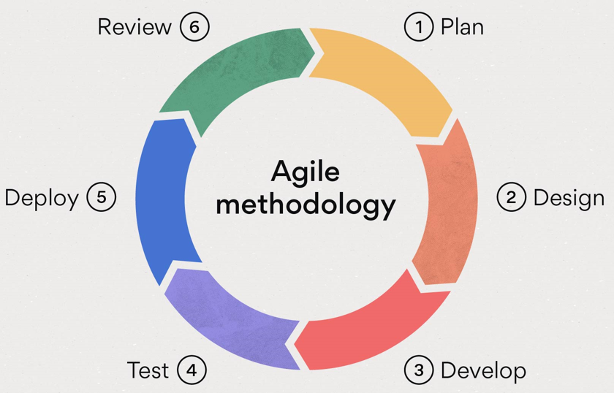
Figure 3.2 Agile methodology
The Agile methodology is a practice that promotes continuous development and testing throughout a project's software development lifecycle. The agile methodology, as opposed to the Waterfall methodology, allows for parallel development and testing.
Agile methodologies attempt to produce the right product by forming small cross-functional self-organizing teams that regularly produce small pieces of functionality, allowing for frequent customer input and course correction as needed. In doing so, Agile attempts to address the problems that traditional "waterfall" methodologies of delivering large products over a long period face, such as client requirements changing frequently, resulting in the delivery of incorrect products.
Stages of Agile
- Phase 1: Requirements
- Phase 2: Design
- Phase 3. Development and Coding
- Phase 4: Integration and Testing
- Phase 5. Implementation and Deployment
- Phase 6: Review
We will use agile methodology as it has great advantages, we can summarize it in two points:-
- The speed of development.
- Customers do not have to wait months or years for exactly what they do not
- want with Agile, they can see the result in a short time.

1.11project plan

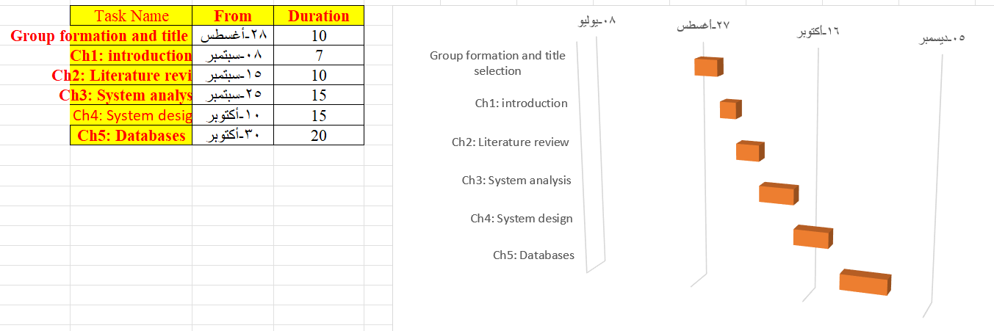

Chapter 2

LITERATURE REVIEW

2.1 Introduction
In the previous chapter, we reviewed difficulties, our project's aims and objectives, project scope and methodology, and the project timeline, which includes the Gantt chart. We will go through some earlier research articles and studies in this chapter. In addition, we look at apps or websites that are similar to our project.

2.2 Related work
The point of the section is to highlight work done by others that somehow ties in with your work. It may be work that you’re basing your work off or work that shows others' attempts to solve the same problem. We discuss briefly published matter that technically relates to our proposed work.
2.2.1 Similar Apps and websites


Sehhaty
(Sehhaty) a national online platform to provide all health services to individuals and aims to be the health guide and reference for individuals in the Kingdom of Saudi Arabia, in integration with the health services and systems in the Ministry of Health.
What Services Do «Sehhaty» Platform Provide?
The platform provides users in the Kingdom with a wide range of health services to facilitate the provision of integrated healthcare to individuals. The services include:
Healthcare steps, through:
- Immediate Consultations.
- Booking and reviewing appointments.
- Virtual appointments.
Easy access through the following services:
- Find medicine.
- Digital health wallet.
- Reviewing sick leaves and medical reports.
Healthy family life through the following services:
- A doctor for every family.
- ​Child’s vaccination record.
- Child’s appointments.
Health lifestyle through:
- Following up vital signs (Know your numbers).
- Steps counting.
- Keeping a list of medicines.
Prevention and protection through:
- COVID-19 screening appointment.
- COVID-19 vaccines appointment.
- COVID-19 vaccination appointment.
Who uses the app?
The «Sehhaty» platform serves all individuals, citizens and residents in the Kingdom, including their children, the elderly, or people with special needs.

What is Language of Service?
The Ministry provides its e-services in Arabic and English.

MOH formulary 

The (MOH formulary) application of pharmaceutical information easily and quickly for health practitioners through smart devices, where the health practitioner can identify all types of approved drugs, and their side effects. The MOH formulary app also provides easy-to-understand information directed to the patient about medications, methods of use and duration of use

Easy access through the following services:
Identify all types of approved drugs, and their side effects. The MOH formulary app also provides easy-to-understand information directed to the patient about medications, methods of use and duration of use
Who uses the app?

The (MOH formulary) application of pharmaceutical information easily and quickly for health practitioners through smart devices, The MOH formulary app also provides easy-to-understand information directed to the patient about medications, methods of use and duration of use

What is Language of Service?
The Ministry provides its e-services in Arabic and English.
 | 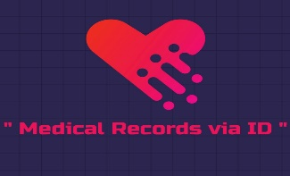 |  | 
Arabic Language |  |  | 
Account for a customer |  |  | 
Account for admin |  | --- | ---
Website |  | --- | ---
Provides patient information |  |  | 
Free |  |  | 

Chapter 3
SYSTEM ANALYSIS

3.1 Introduction
In the first chapter, we discuss the introduction of the project showing in it the problems that face the manual system users that motivate us to develop this system; also, we discuss the objective of the system and the timeframe of project tasks.
In the second chapter, we discuss the related systems for our project showing the advantages and disadvantages of every system to avoid in our system.
In this chapter, we will talk about the methods that we use to gather data for the application display the system requirements that are Functional and non-functional requirements of the application and define the system users and their functions.

3.2 Data Collection from Questionnaire
The important step for building knowledge for a new system or developing an existing system is information gathering. There are many techniques for information gathering.
We make the Face-to-Face interviews as this is the most common technique for gathering requirements and has many positive items like direct answers from the persons and there is the ability to explain the questions and answer if they have some ambiguity. We sit down with the system users and ask them what they need. The discussion was planned ahead of time-based on the type of requirements we are looking for.
We visited some hospitals and ask the doctors open-ended questions to get the interviewee to start talking and then ask probing questions to cover all the requirements that we need.
Then we search the internet for Online Systems to get information about how they manage the process of managing the medical records of patients .
A "google form" was used to develop an online questionnaire in Arabic, and 44 people responded. The questionnaire begins with confirming that the participants have accepted to participate in the study as shown in Figure (3-1).
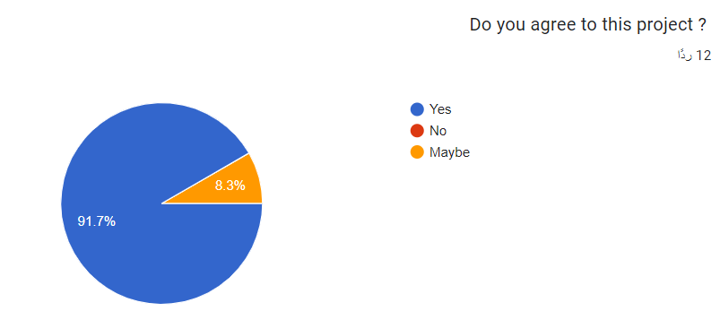
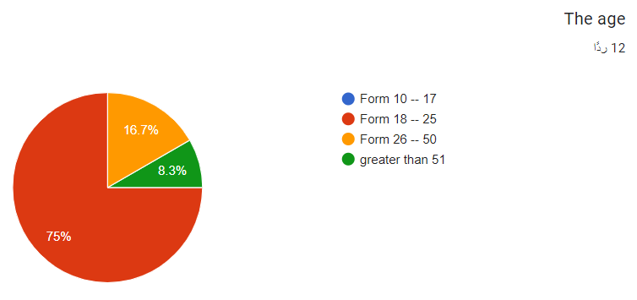
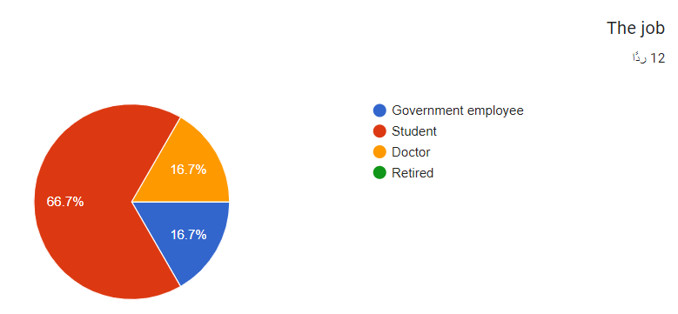
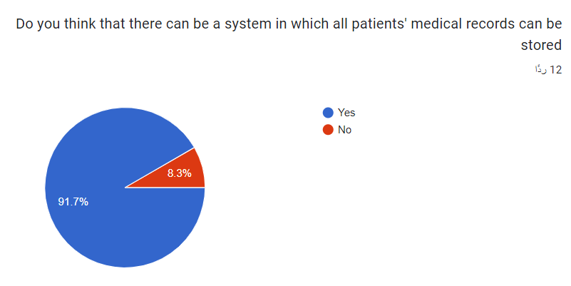
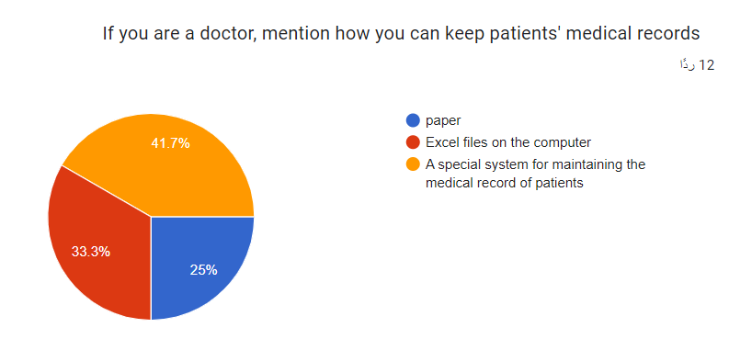
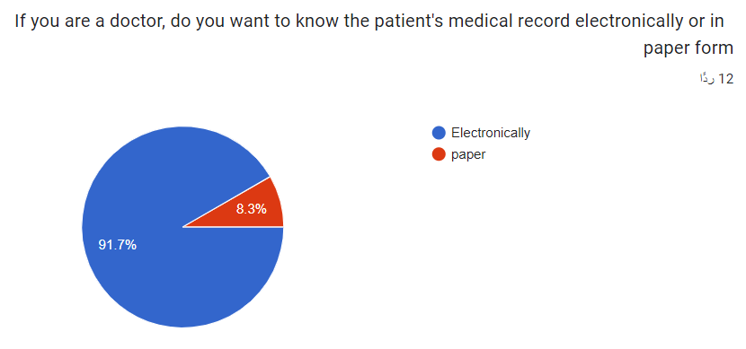

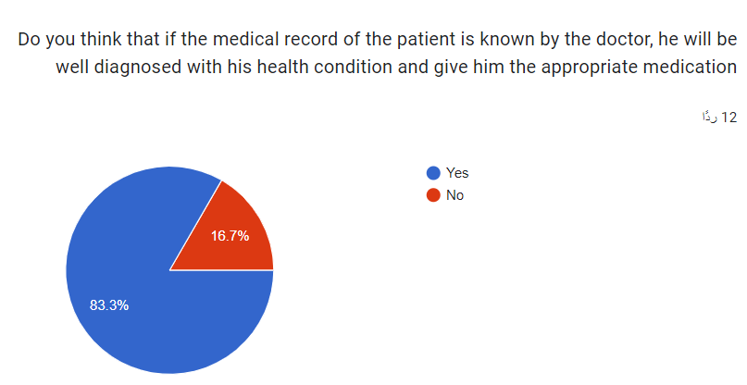
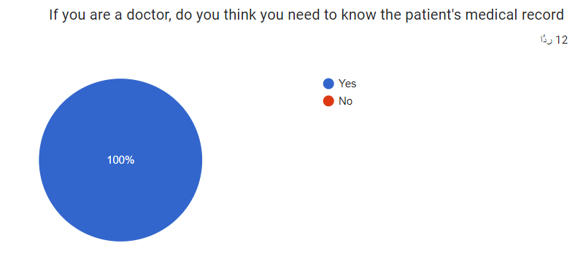
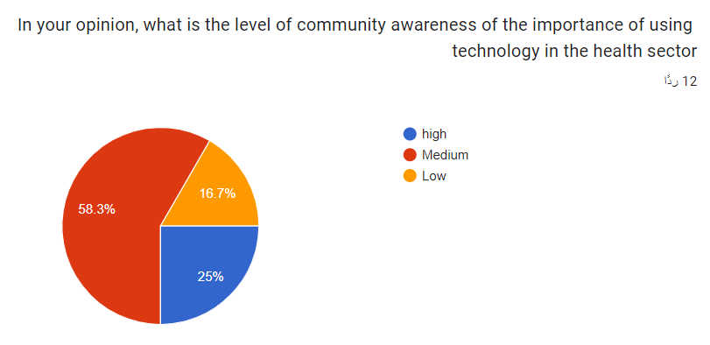

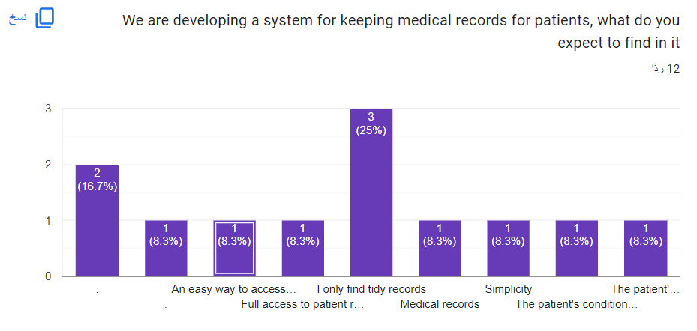

3.3 REQUIREMENTS ELICITATION
Requirements elicitation is the practice of researching and discovering the requirements of a system from all the stakeholders.

3.3.1 FUNCTIONAL REQUIREMENTS
In Functional Requirement we make a description of the service that the software must offer. We also describe a software system or its component, The function is the software inputs, its behavior, and outputs.
It could be, data processing, business process, user interaction, or any other specific function that defines the function the system is likely to perform

3.3.1.1 The patient requirements
- The patient should be able to log in/log out of the system.
- The patient should be able to edit his profile.
- The patient should be able to view his medical history.
3.3.1.2 The Admin requirements
- The admin should be able to log in/log out of the system.
- The admin should be able to edit his profile.
- The admin should be able to manage the patients (add – edit – delete).
- The admin should be able to manage the doctors (add – edit – delete).
- The admin should be able to manage the employees (add – edit – delete).
3.3.1.3 The doctor requirements
- The doctor should be able to log in/log out of the system.
- The doctor should be able to edit his profile.
- The doctor should be able to search for the patient.
- The doctor should be able to add a new medical record to the patient.
- The doctor should be able to view the medical history of any patient.
3.3.1.3 The employee requirements
- The employee should be able to log in/log out of the system.
- The employee should be able to edit his profile.
- The employee should be able to search for the patient.
- The employee should be able to manage patients (show – add – edit – delete).
- The employee should be able to print patient records.

3.3.2 NON-FUNCTIONAL REQUIREMENTS
The official definition for a non-functional requirement specifies how the system should behave: "A non-functional requirement is a statement of how a system must behave".
- The system should automate paperwork to reduce duplication of effort and increase users' efficiency
- The system has a very user-friendly interface.
- The system should be available for all users.
- The system should display 100% accurate data.
- The system can serve more than 1000000 users.
- The system should be able to find a user's record very fast.
- The level of accuracy in the system will be higher.
- The system doesn't let no information is repeated anywhere
- The system will store the information immediately.
- The system should be easy to operate.
- This system provides quick addition, deletion, or search for various types of data, which are a part of the system.
- The reports of the system can be retried as and when required.

3.4 REQUIREMENTS SPECIFICATION
A use case diagram is used to represent the dynamic behavior of a system. It encapsulates the system's functionality by incorporating use cases, actors, and their relationships.
As shown below in figure 3.1, the patient can log in, log out, update his profile and view the medical records that the doctor added to him previously.
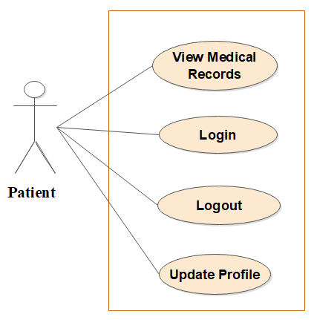
Figure 3.1 patient use case diagram

As shown below in figure 3.2, the doctor can log in, log out, update his profile, search for the patient by ID to know his data, add medical records to the patient and view the patient's medical records that the doctors added to the patient previously.
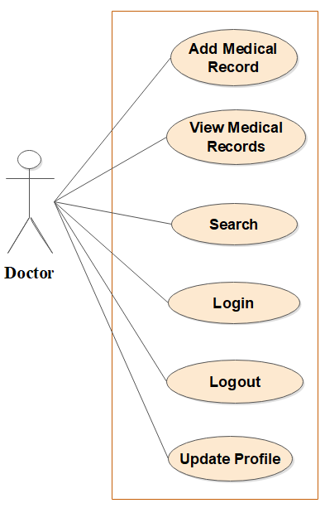
Figure 3.2 doctor use case diagram

As shown below in figure 3.3, the employee can log in, logout, update the profile, search for a patient by ID to know his data, and show his medical records to be able to print it, also the employee can manage patients by adding new patient, edit exist patient or delete existing patient.
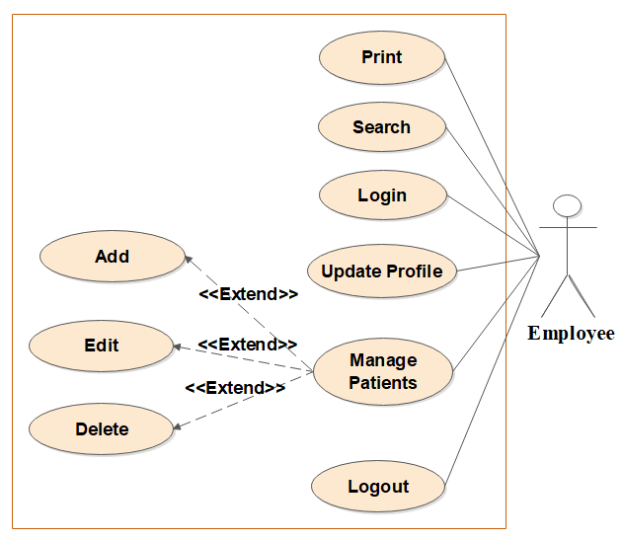
Figure 3.3 employee use case diagram

As shown below in figure 3.4, the admin can log in, log out, update the profile, and manage the patients by adding new patients, editing existing patients, or deleting existing patients. In addition, the admin can manage the employees by adding new employees, editing existing employees, or deleting existing employees. In addition, the admin can manage the doctors by adding new doctors, edit exist doctors, or deleting existing doctors.

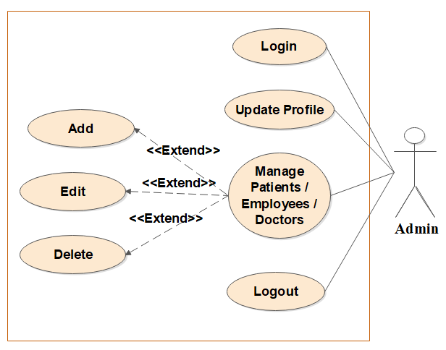
Figure 3.4 admin use case diagram

As shown below in figure 3.5, shows all the system users and every case that he can do.
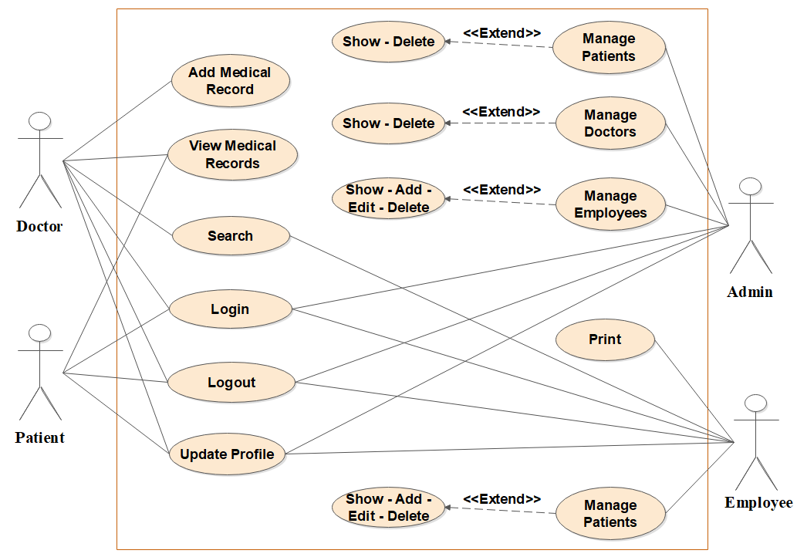
Figure 3.5 main use case diagram

CHAPTER 4
SYSTEM DESIGN

4.1 Introduction
Because specific requirements must be met by the proposed application to fulfill project objectives, we perform the system analysis by drawing (UML design) in this chapter. The Unified Modeling Language's goal is to offer a comprehensive enough vocabulary of object-based concepts and diagramming tools to model any systems development project from analysis through design.

4.2 Structural Static Models
The structural static models are a diagrammatic representation depending on the modeling language that you use. In this section, we represent the class diagrams.

4.2.1 Class diagram
Displays the classes used in the system and collaboration and their relationships, as each class contains three elements: the class name, the Attributes, and the operations. The class diagram is the main building block of object-oriented modeling. It is used for general conceptual modeling of the structure of the application, and detailed modeling translating the models into programming code. Class diagrams can also be used for data modeling.
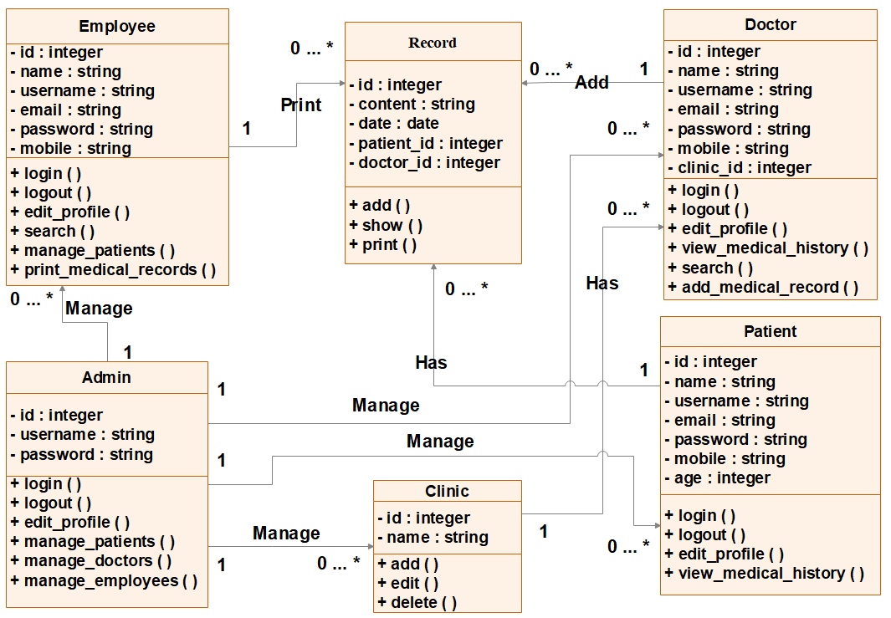
Figure 4.1 Class diagram

4.3 Dynamic Models
The dynamic model is used to express and model the behavior of the system over time. It includes support for activity diagrams, state diagrams, sequence diagrams, and extensions including business process modeling.

4.3.1 Sequence diagram
A sequence diagram simply depicts the interaction between objects in sequential order i.e. the order in which these interactions take place. We can also use the terms event diagrams or event scenarios to refer to a sequence diagram. Sequence diagrams describe how and in what order the objects in a system function. These diagrams are widely used by businessmen and software developers to document and understand requirements for new and existing systems.
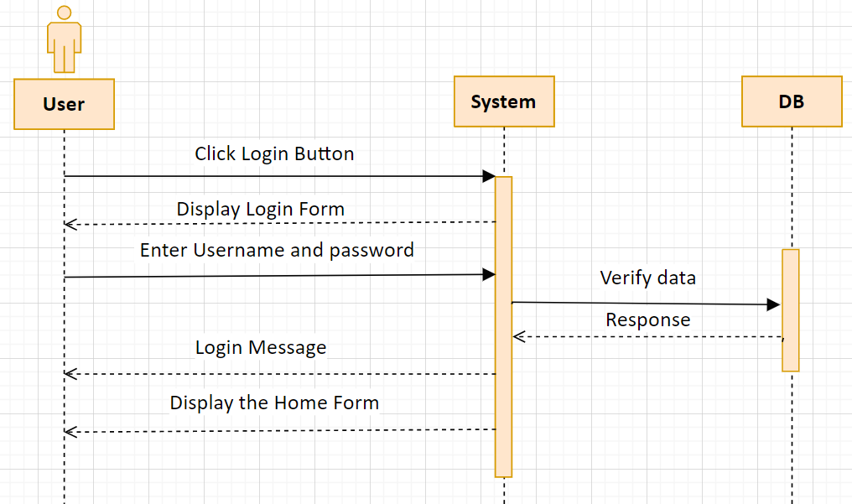
Figure 4.2 Login sequence diagram

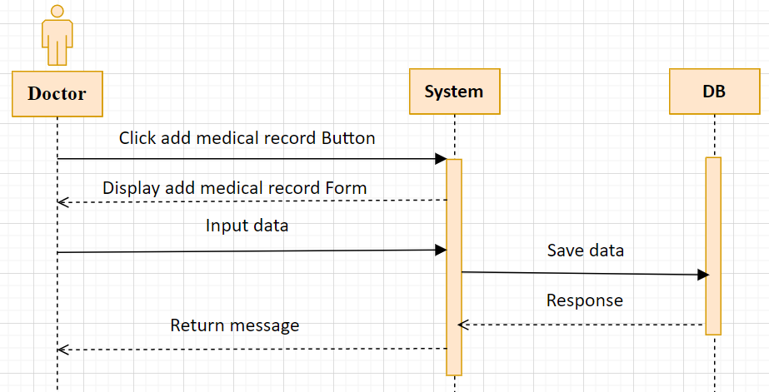
Figure 4.3 doctor adds medical record sequence diagram

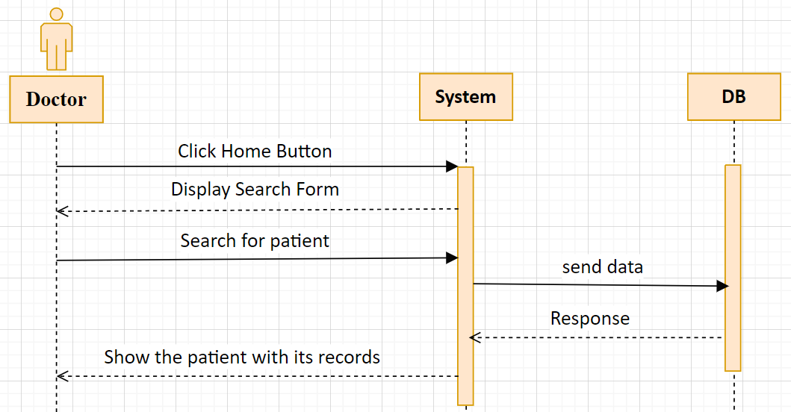
Figure 4.4 doctor search sequence diagram
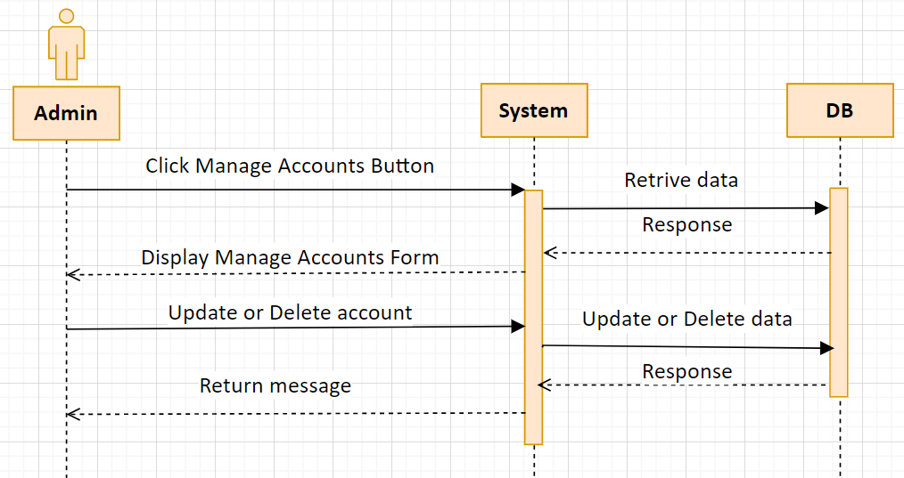
Figure 4.5 Admin manage users sequence diagram
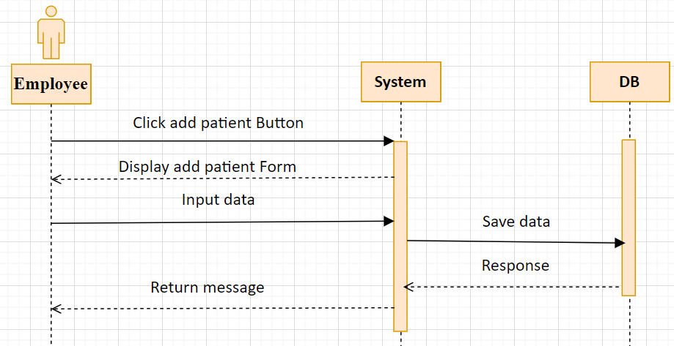
Figure 4.6 employee adds patient sequence diagram

4.3.2 Activity Diagram
Activity diagrams are graphic representations of the workflow of activities and stepwise actions with support for selection, repetition, and concurrency.

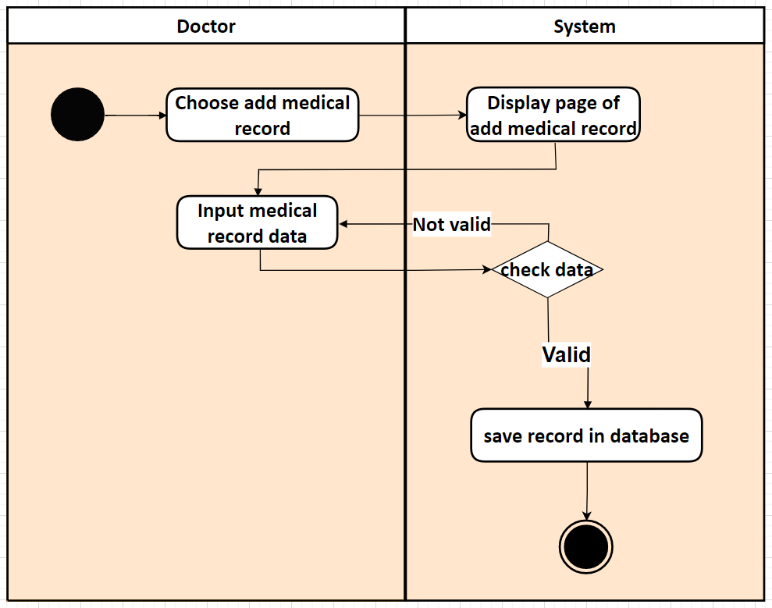
Figure 4.7 Doctor Add medical record

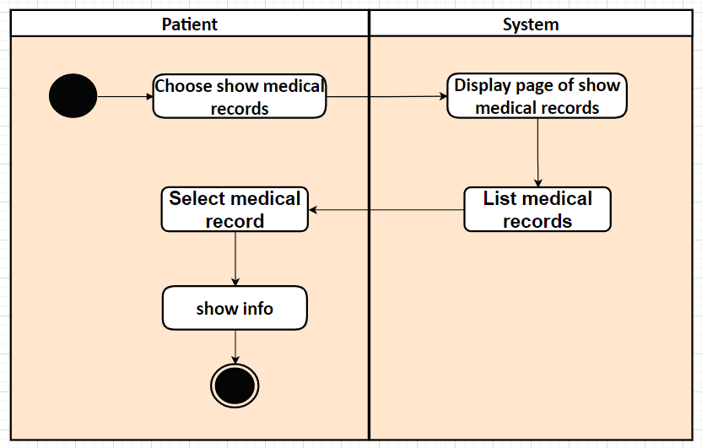
Figure 4.8 Patient Show medical records
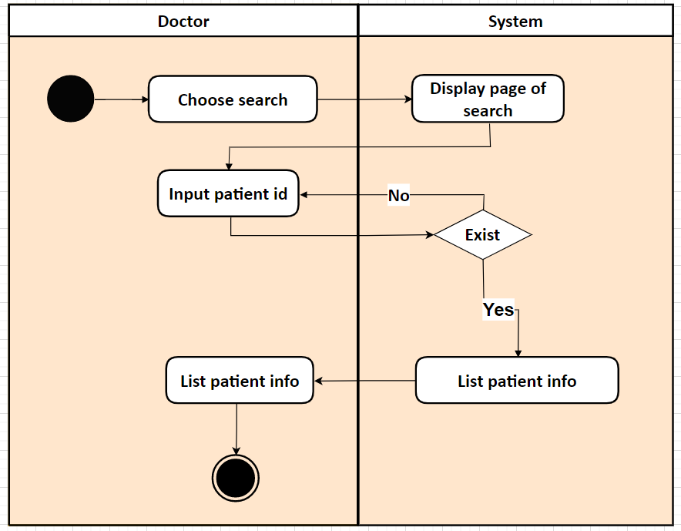
Figure 4.9 Doctor search
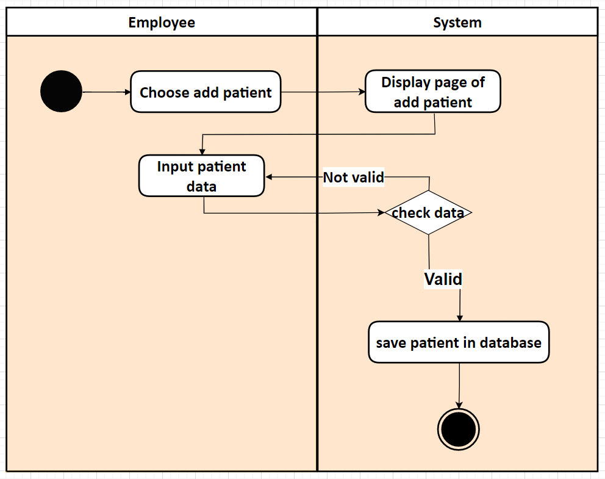
Figure 4.10 Employee adds patient

.

CHAPTER 5

DATABASES

5.1 Data Modeling
In this section, the basic structure of the tables composing the database for the project is shown along with information about primary and foreign keys.
A design methodology shown in figure (5-1) is made up of several phases, each with its own set of stages that lead the designer through the appropriate procedures for each step of the project. A design approach also aids database development and project management by allowing the designer to plan, manage, control, and assess projects. Furthermore, it is a method for assessing and modeling a set of database needs in a consistent and orderly manner.
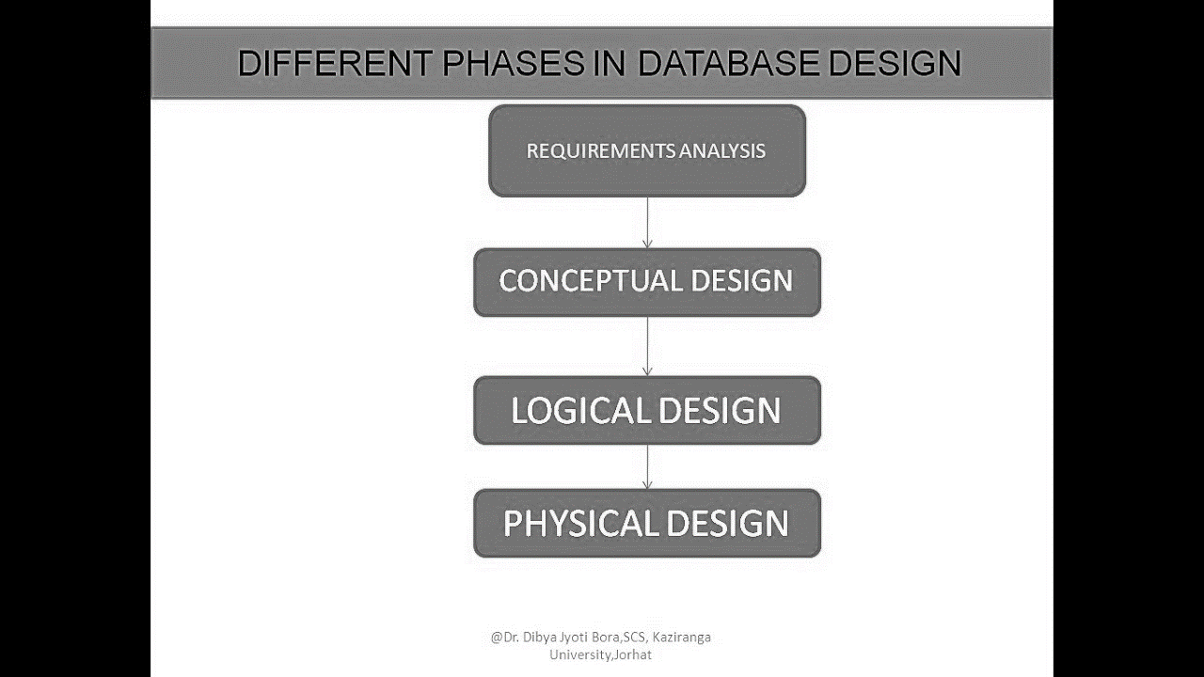
Figure 5.1: Database design phases
Conceptual design
At the conceptual level, data is represented in the form of various database tables. Our app database contains admin, patient, doctor, employee, and record tables which will be visible to users but users are unaware of their storage. Also referred to as logical schema, it describes what kind of data is to be stored in the database.
Logical design
They are less abstract and provide greater detail about the concepts and relationships in the domain under consideration. One of several formal data modeling notation systems is followed. These indicate data attributes, such as data types and their corresponding lengths, and show the relationships among entities.
Physical design
They provide a schema for how the data will be physically stored within a database. As such, they’re the least abstract of all. They offer a finalized design that can be implemented as a relational database, including associative tables that illustrate the relationships among entities as well as the primary keys and foreign keys that will be used to maintain those relationships. The project database's physical design is shown in figure 5-2 which shows the database schema.

5.2 Database Entities and Attributes (Schema)
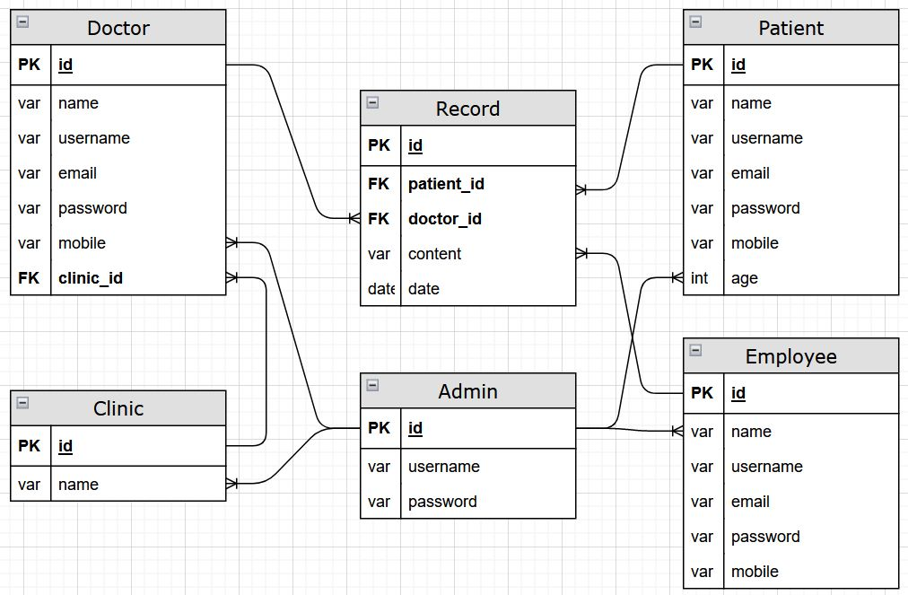
Figure 5.2: The database schema

Table 5.1: Database entities and their attribute.
Entity | Description | Attributes | Data Type | Length
Patient | Entity for patient | Id | Integer | 11
 |  | Name | Varchar | 50
 |  | Username | Varchar | 50
 |  | Email | Varchar | 50
 |  | Password | Varchar | 50
 |  | Mobile | Varchar | 10
 |  | Age | Integer | 11
Doctor | Entity for doctor | Id | Integer | 11
 |  | Name | Varchar | 50
 |  | Username | Varchar | 50
 |  | Email | Varchar | 50
 |  | Password | Varchar | 50
 |  | Mobile | Varchar | 10
 |  | Clinic | Varchar | 20
Employee | Entity for employee | Id | Integer | 11
 |  | Name | Varchar | 50
 |  | Username | Varchar | 50
 |  | Email | Varchar | 50
 |  | Password | Varchar | 50
 |  | Mobile | Varchar | 10
Admin | Entity for admin | Id | Integer | 11
 |  | Username | Varchar | 50
 |  | Password | Varchar | 50
Record | Entity for patient records | Id | Integer | 11
 |  | Content | Varchar | 255
 |  | Date | Date | -
 |  | Patient_id | Integer | 11
 |  | Doctor_id | Integer | 11
Clinic | Entity for clinic | Id | Integer | 11
 |  | Name | Varchar | 50

5.3 Database Relationships Description
- Every patient has a set of medical records so this entity has the foreign key of the patient.
- Every doctor has a set of medical records so this entity has the foreign key of the doctor.
- Every clinic has a set of doctors so this entity has the foreign key of the doctor.

5.4 Interfaces
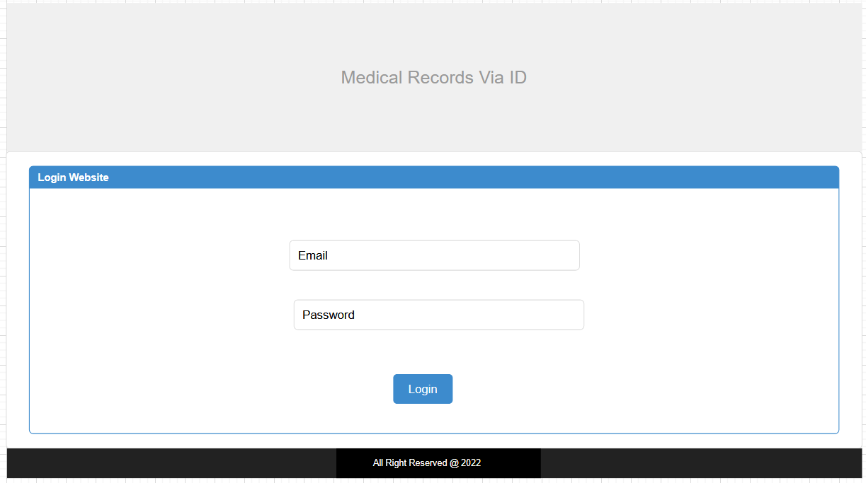
Figure 5.3: Login interface

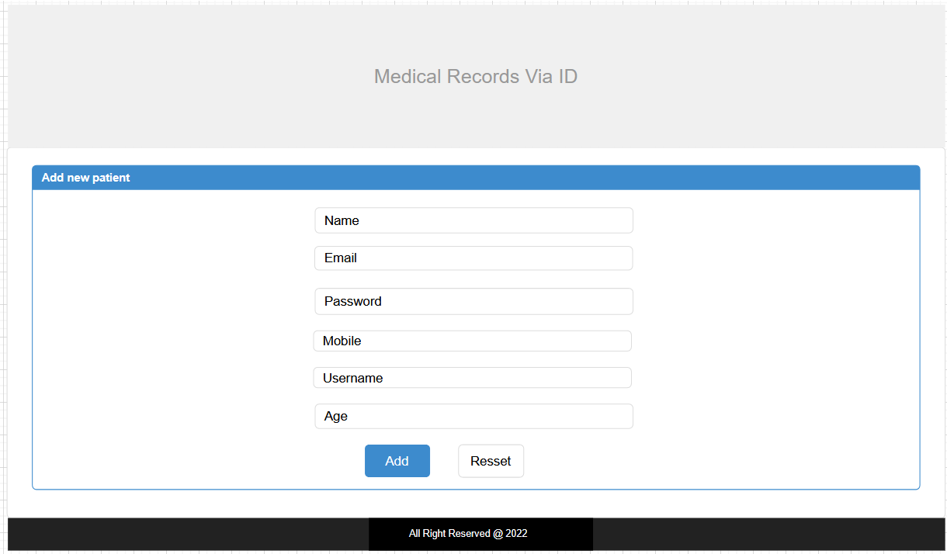
Figure 5.4: add new patient interface

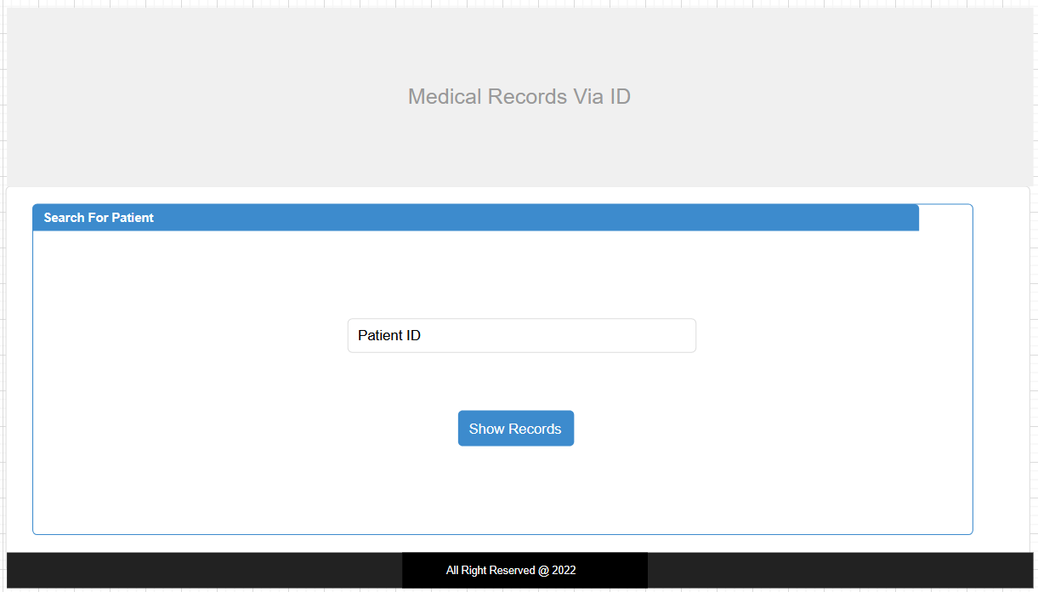
Figure 5.5: Search for a patient interface

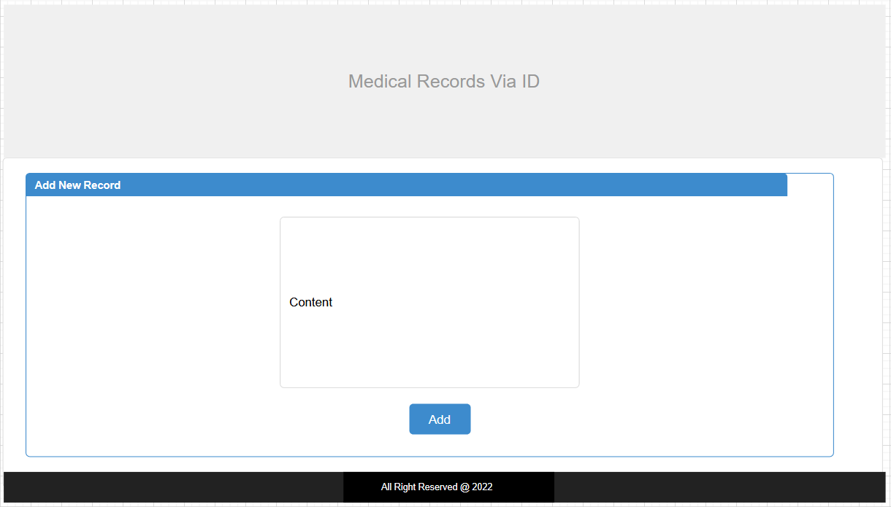
Figure 5.6: Add new medical record interface

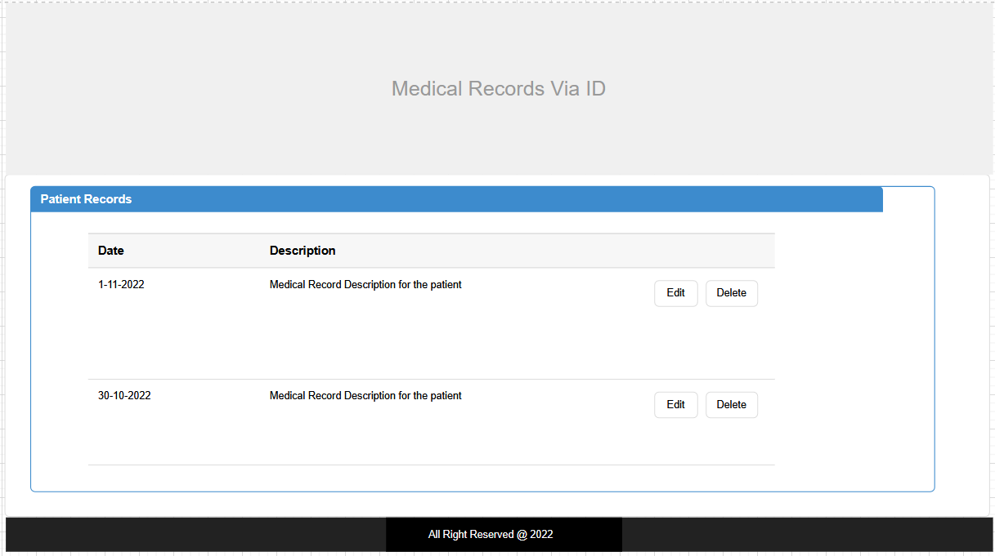
Figure 5.7: Patient medical records interface

CHAPTER 6
DATABASE DESIGN

6.1 Database design
Database design is the process of producing a detailed data model of a Mobile Application for Car maintenance database .This data model contains all the needed logical and physical design choices and physical storage parameters needed to generate a design in a data definition language, which can then be used to create a database. A fully attributed data model contains detailed attributes for each entity.
The process of doing database design generally consists of a number of steps which will be carried out by the database designer. Usually, the designer must:
- Determine the data to be stored in the database.
- Determine the relationships between the different data elements.
- Superimpose a logical structure upon the data on the basis of these relationships.
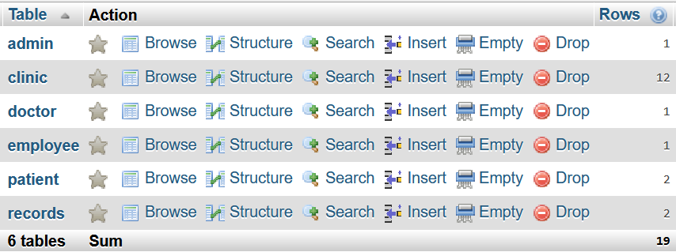
Figure 6.1: Database tables

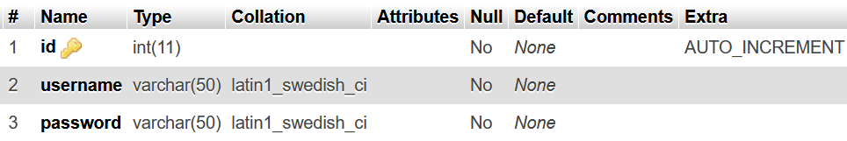
Figure 6.2: Admin database table
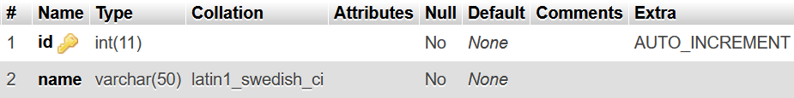
Figure 6.3: Clinic database table

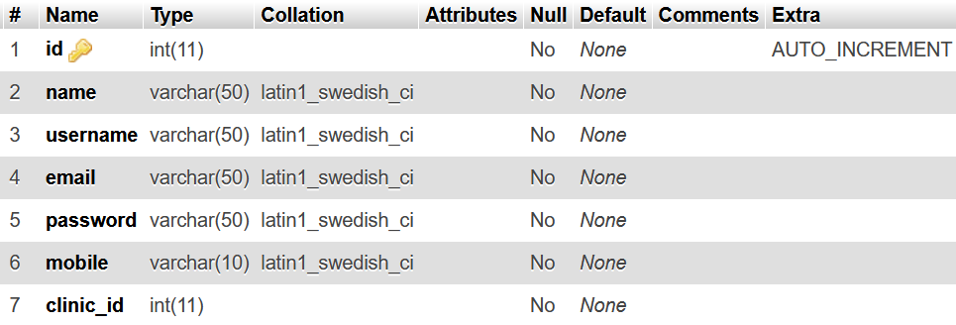
Figure 6.4: Doctor database table

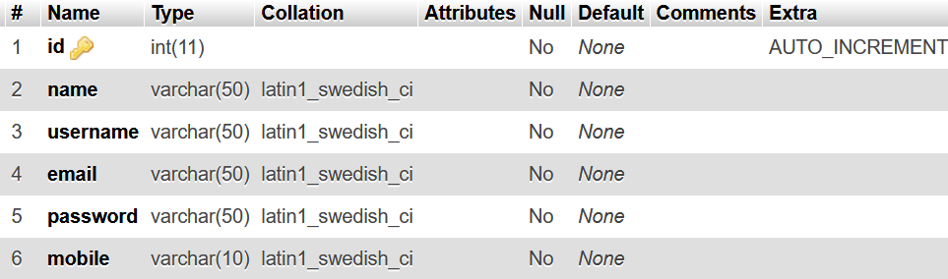
Figure 6.5: Employee database table

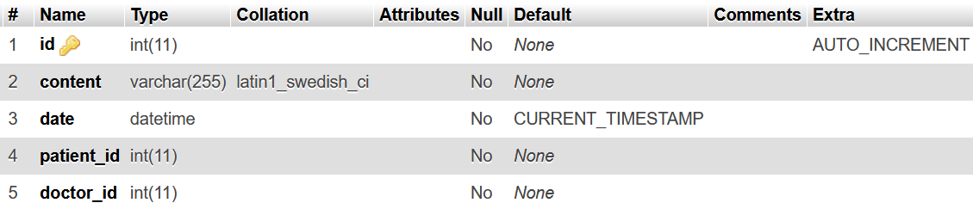
Figure 6.6: Records database table
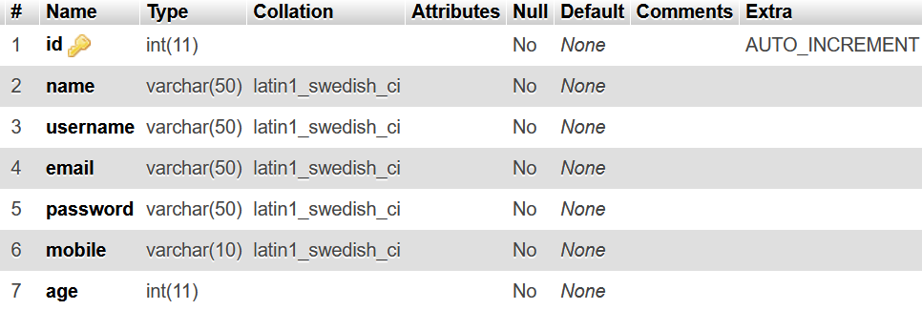
Figure 6.7: Patient database table

CHAPTER 7
USER INTERFACE

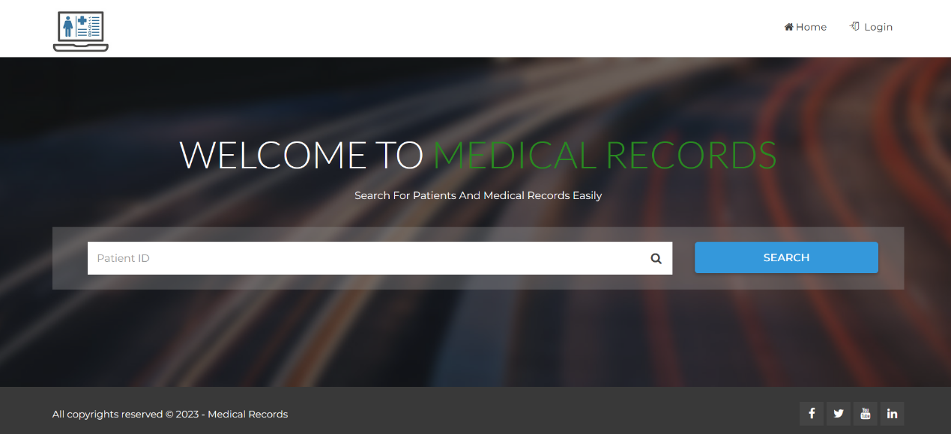
Figure 7.1: Home interface

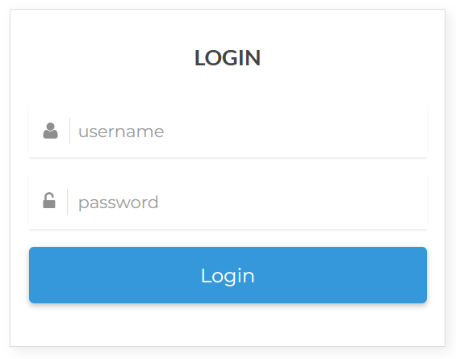
Figure 7.2: Login interface

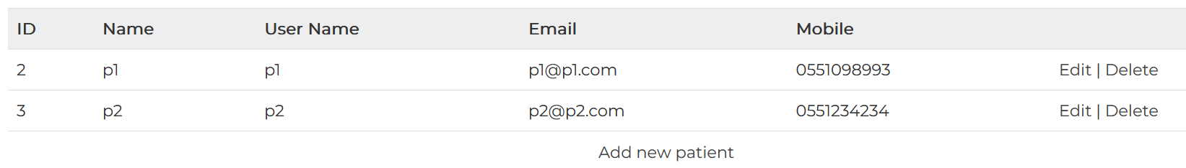
Figure 7.3: Admin show patients interface
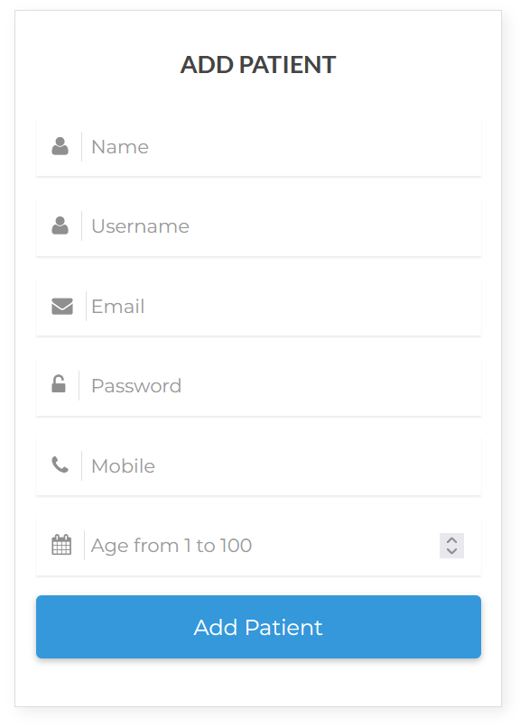
Figure 7.4: Admin add patient interface

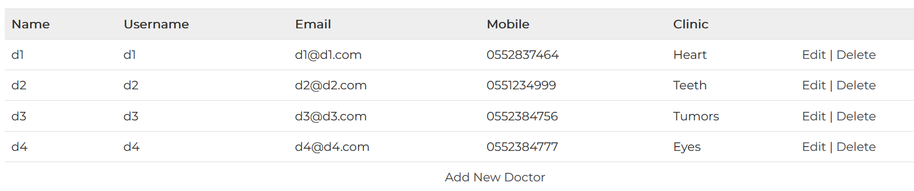
Figure 7.5: Admin show doctors interface

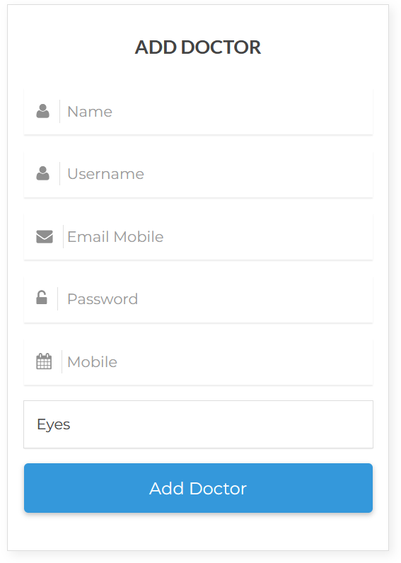
Figure 7.6: Admin add doctor interface

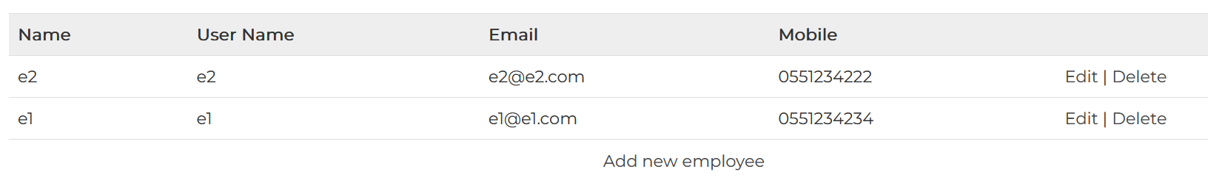
Figure 7.7: Admin show employees interface

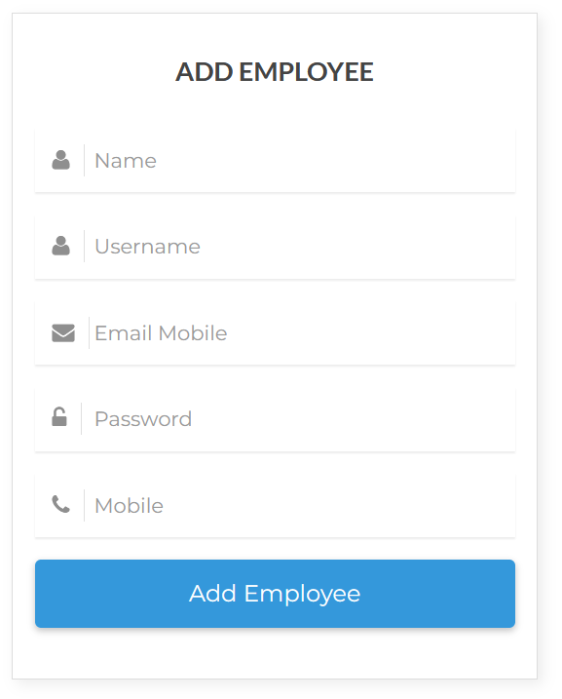
Figure 7.8: Admin add employee interface

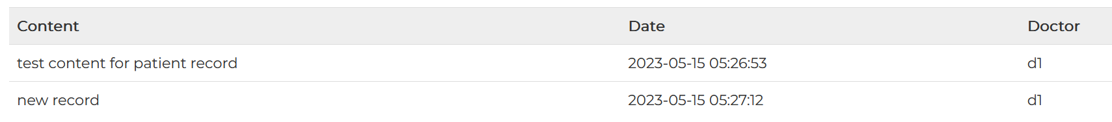
Figure 7.9: Patient show records interface

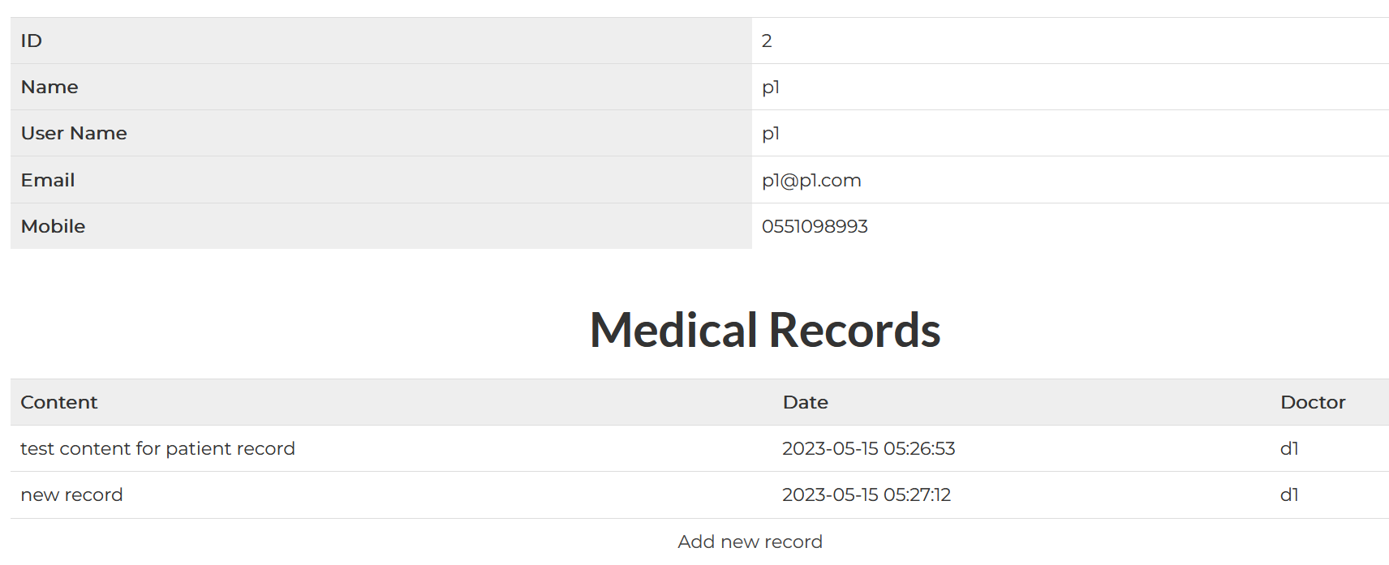
Figure 7.10: Doctor show patient records interface

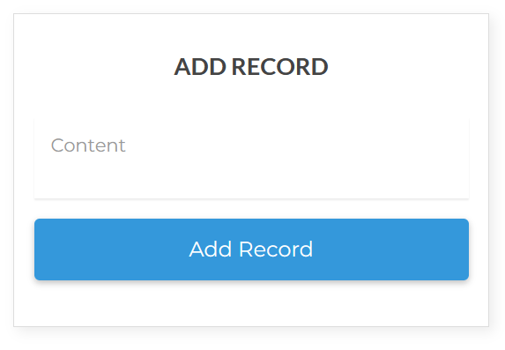
Figure 7.11: Doctor adds record interface

APPENDIX (CODES)

Search
<?php include 'header.php';?>

<?php
// if he not logged in ; redirect to the index page
if ($_SESSION ['user_type'] != "doctor" && $_SESSION ['user_type'] != "employee") {
echo "<script>location.href = 'index.php';</script>";
}
?>

<div class="page-header"
style="background: url(assets/img/banner1.jpg);">
<div class="container">
<div class="row">
<div class="col-md-12">
<div class="breadcrumb-wrapper">
<h2 class="page-title">Search Result</h2>
</div>
</div>
</div>
</div>
</div>
<br/>
<br/>

<?php
// get all information for the patient
$patient_query = "SELECT * from patient WHERE id = '$_POST[id]'";
$patient_result = mysql_query ( $patient_query ) or die ( 'error : ' . mysql_error () );
$patient_row = mysql_fetch_array($patient_result);

if (mysql_num_rows($patient_result) == 0) {
echo "<h3>Sorry there are no patient with this ID</h3>";
} else {
// get all information for the record
$record_query = "SELECT records.*, doctor.name AS doctor_name from records LEFT JOIN doctor ON records.doctor_id = doctor.id WHERE records.patient_id = '$_POST[id]'";
$record_result = mysql_query ( $record_query ) or die ( 'error : ' . mysql_error () );
?>
<div class="post">
<table width="100%" align="center" cellpadding=5 cellspacing=5 class="table">
<tr>
<th>ID</th>
<td><?php echo $patient_row['id']?></td>
</tr>
<tr>
<th>Name</th>
<td><?php echo $patient_row['name']?></td>
</tr>
<tr>
<th>User Name</th>
<td><?php echo $patient_row['username']?></td>
</tr>
<tr>
<th>Email</th>
<td><?php echo $patient_row['email']?></td>
</tr>
<tr>
<th>Mobile</th>
<td><?php echo $patient_row['mobile']?></td>
</tr>
</table>
</div>

<br/>
<h2 align="center">Medical Records</h2>

<div class="post">
<table width="100%" align="center" cellpadding=5 cellspacing=5 class="table">
<tr>
<th>Content</th>
<th>Date</th>
<th>Doctor</th>
</tr>
<?php while ($record_row = mysql_fetch_array($record_result)) { ?>
<tr>
<td><?php echo $record_row['content']?></td>
<td><?php echo $record_row['date']?></td>
<td><?php echo $record_row['doctor_name']?></td>
</tr>
<?php }?>

<?php // check the user type
if($_SESSION['user_type'] == "doctor") {
echo "<tr><td align='center' colspan='3'><a href='doctor_add_patient_record.php?patient_id=$_POST[id]'>Add new record</a></td></tr>";
} else if($_SESSION['user_type'] == "employee") {
echo "<tr><td align='center' colspan='3'><a href='employee_print_patient_record.php?patient_id=$_POST[id]'>Print Records</a></td></tr>";
}?>
</table>
</div>
<?php } ?>

<?php include 'footer.php';?>

Patient show medical records
<?php include 'header.php';?>

<?php
// if he not logged in ; redirect to the index page
if ($_SESSION ['user_type'] != "patient") {
echo "<script>location.href = 'index.php';</script>";
}
?>

<?php
// get all information for the record
$record_query = "SELECT records.*, doctor.name AS doctor_name from records LEFT JOIN doctor ON records.doctor_id = doctor.id WHERE records.patient_id = '$_SESSION[user_id]'";
$record_result = mysql_query ( $record_query ) or die ( 'error : ' . mysql_error () );
?>

<div class="page-header"
style="background: url(assets/img/banner1.jpg);">
<div class="container">
<div class="row">
<div class="col-md-12">
<div class="breadcrumb-wrapper">
<h2 class="page-title">Your Records</h2>
</div>
</div>
</div>
</div>
</div>
<br/>
<br/>

<div class="post">
<table width="100%" align="center" cellpadding=5 cellspacing=5 class="table">
<tr>
<th>Content</th>
<th>Date</th>
<th>Doctor</th>
</tr>
<?php while ($record_row = mysql_fetch_array($record_result)) { ?>
<tr>
<td><?php echo $record_row['content']?></td>
<td><?php echo $record_row['date']?></td>
<td><?php echo $record_row['doctor_name']?></td>
</tr>
<?php }?>
</table>
</div>

<?php include 'footer.php';?>

Logout
<?php include "base.php"; $_SESSION = array(); session_destroy(); ?>
<meta http-equiv="refresh" content="0;index.php">

Login
<?php include_once 'header.php';?>

<div class="page-header"
style="background: url(assets/img/banner1.jpg);">
<div class="container">
<div class="row">
<div class="col-md-12">
<div class="breadcrumb-wrapper">
<h2 class="page-title">Login to account</h2>
</div>
</div>
</div>
</div>
</div>

<?php
if (isset ( $_POST ['username'] )) {
$username = ( $_POST ['username'] );
$password = ( $_POST ['password'] );
$checklogin = mysql_query ( "SELECT * FROM patient WHERE username = '" . $username . "' AND password = '" . $password . "'" ) or die (" error patient " . mysql_error ());

if (mysql_num_rows ( $checklogin ) == 1) {
$row = mysql_fetch_array ( $checklogin );
$email = $row ['email'];
$username = $row ['username'];
$name = $row ['name'];
$type = "patient";

$_SESSION ['username'] = $username;
$_SESSION ['name'] = $name;
$_SESSION ['user_id'] = $row ['id'];
$_SESSION ['email'] = $email;
$_SESSION ['user_type'] = $type;
$_SESSION ['LoggedIn'] = 1;

echo "<h1>Success</h1>";
echo "<p>We are now redirecting you to the member area.</p>";
// echo "<meta http-equiv='refresh' content='=2;index.php' />";
echo "<script>location.href = 'index.php';</script>";
} else {
$checklogin = mysql_query ( "SELECT * FROM doctor WHERE username = '" . $username . "' AND password = '" . $password . "'" );

if (mysql_num_rows ( $checklogin ) == 1) {
$row = mysql_fetch_array ( $checklogin );
$email = $row ['email'];
$username = $row ['username'];
$name = $row ['name'];
$type = "doctor";

$_SESSION ['username'] = $username;
$_SESSION ['name'] = $name;
$_SESSION ['user_id'] = $row ['id'];
$_SESSION ['email'] = $email;
$_SESSION ['user_type'] = $type;
$_SESSION ['LoggedIn'] = 1;

echo "<h1>Success</h1>";
echo "<p>We are now redirecting you to the member area.</p>";
// echo "<meta http-equiv='refresh' content='=2;index.php' />";
echo "<script>location.href = 'index.php';</script>";
} else {
$checklogin = mysql_query ( "SELECT * FROM admin WHERE username = '" . $username . "' AND password = '" . $password . "'" );

if (mysql_num_rows ( $checklogin ) == 1) {
$row = mysql_fetch_array ( $checklogin );
$email = $row ['email'];
$username = $row ['username'];
$name = $row ['name'];
$type = "admin";

$_SESSION ['username'] = $username;
$_SESSION ['name'] = $name;
$_SESSION ['user_id'] = $row ['id'];
$_SESSION ['email'] = $email;
$_SESSION ['user_type'] = $type;
$_SESSION ['LoggedIn'] = 1;

echo "<h1>Success</h1>";
echo "<p>We are now redirecting you to the member area.</p>";
// echo "<meta http-equiv='refresh' content='=2;index.php' />";
echo "<script>location.href = 'index.php';</script>";
} else {
$checklogin = mysql_query ( "SELECT * FROM employee WHERE username = '" . $username . "' AND password = '" . $password . "'" );

if (mysql_num_rows ( $checklogin ) == 1) {
$row = mysql_fetch_array ( $checklogin );
$email = $row ['email'];
$username = $row ['username'];
$name = $row ['name'];
$type = "employee";

$_SESSION ['username'] = $username;
$_SESSION ['name'] = $name;
$_SESSION ['user_id'] = $row ['id'];
$_SESSION ['email'] = $email;
$_SESSION ['user_type'] = $type;
$_SESSION ['LoggedIn'] = 1;

echo "<h1>Success</h1>";
echo "<p>We are now redirecting you to the member area.</p>";
// echo "<meta http-equiv='refresh' content='=2;index.php' />";
echo "<script>location.href = 'index.php';</script>";
} else {
echo "<h1>Error</h1>";
echo "<p>Sorry, your account could not be found. try again</a>.</p>";
}
}
}
}
} else {
?>

<section id="content">
<div class="container">
<div class="row">
<div class="col-sm-6 col-sm-offset-4 col-md-4 col-md-offset-4">
<div class="page-login-form box">
<h3>Login</h3>
<form role="form" class="login-form" method="post">
<div class="form-group">
<div class="input-icon">
<i class="icon fa fa-user"></i> <input type="text"
id="sender-email" class="form-control" name="username"
placeholder="username">
</div>
</div>
<div class="form-group">
<div class="input-icon">
<i class="icon fa fa-unlock-alt"></i> <input type="password" name="password"
class="form-control" placeholder="password">
</div>
</div>
<button class="btn btn-common log-btn">Login</button>
</form>
</div>
</div>
</div>
</div>
</section>

<?php } ?>

<?php include_once 'footer.php';?>

Employee print records
<?php include 'header.php';?>

<?php
// if he not logged in ; redirect to the index page
if ($_SESSION ['user_type'] != "employee") {
echo "<script>location.href = 'index.php';</script>";
}
?>

<script>
window.print ();
</script>

<?php
// get all information for the record
$record_query = "SELECT records.*, doctor.name AS doctor_name from records LEFT JOIN doctor ON records.doctor_id = doctor.id WHERE records.patient_id = '$_GET[patient_id]'";
$record_result = mysql_query ( $record_query ) or die ( 'error : ' . mysql_error () );
?>

<h2 class="page-title">Patient Records</h2>

<div class="post">
<table width="100%" align="center" cellpadding=5 cellspacing=5 class="table">
<tr>
<th>Content</th>
<th>Date</th>
<th>Doctor</th>
</tr>
<?php while ($record_row = mysql_fetch_array($record_result)) { ?>
<tr>
<td><?php echo $record_row['content']?></td>
<td><?php echo $record_row['date']?></td>
<td><?php echo $record_row['doctor_name']?></td>
</tr>
<?php }?>
</table>
</div>

<?php include 'footer.php';?>

Doctor add record
<?php include_once 'header.php';?>

<?php
// if he not logged in ; redirect to the index page
if ($_SESSION ['user_type'] != "doctor") {
echo "<script>location.href = 'index.php';</script>";
}
?>

<div class="page-header"
style="background: url(assets/img/banner1.jpg);">
<div class="container">
<div class="row">
<div class="col-md-12">
<div class="breadcrumb-wrapper">
<h2 class="page-title">Add Patient Record</h2>
</div>
</div>
</div>
</div>
</div>

<?php
if (! empty ( $_POST ['content'] )) {
$content = ( $_POST ['content'] );
$doctor_id = ( $_SESSION ['user_id'] );
$patient_id = ( $_POST ['patient_id'] );

$add_query = mysql_query ( "INSERT INTO records (content, doctor_id, patient_id )
VALUES('$content', '$doctor_id', '$patient_id')" ) or die ( mysql_error () );

if ($add_query) {
echo "<h1>Success of addition</h1>";
} else {
echo "<h1>Error</h1>";
echo "<p>Sorry, your add failed. Please go back and try again.</p>";
}
} else { ?>
<section id="content">
<div class="container">
<div class="row">
<div class="col-sm-6 col-sm-offset-4 col-md-4 col-md-offset-4">
<div class="page-login-form box">
<h3>Add Record</h3>
<form role="form" class="login-form" method="post">
<input type="hidden" value="<?php echo $_GET['patient_id'];?>" name="patient_id" />

<div class="form-group">
<div class="input-icon">
<textarea type="text" required id="sender-email" class="form-control" name="content" placeholder="Content"></textarea>
</div>
</div>
<button class="btn btn-common log-btn">Add Record</button>
</form>
</div>
</div>
</div>
</div>
</section>
<?php } ?>

<?php include_once 'footer.php';?>

Admin show patients
<?php include 'header.php';?>

<?php
// if he not logged in ; redirect to the index page
if ($_SESSION ['user_type'] != "admin") {
echo "<script>location.href = 'index.php';</script>";
}
?>

<?php
// get all information for the patient
$patient_query = "SELECT * from patient";
$patient_result = mysql_query ( $patient_query ) or die ( 'error : ' . mysql_error () );
?>

<div class="page-header"
style="background: url(assets/img/banner1.jpg);">
<div class="container">
<div class="row">
<div class="col-md-12">
<div class="breadcrumb-wrapper">
<h2 class="page-title">All Patients</h2>
</div>
</div>
</div>
</div>
</div>
<br/>
<br/>

<div class="post">
<table width="100%" align="center" cellpadding=5 cellspacing=5 class="table">
<tr>
<th>ID</th>
<th>Name</th>
<th>User Name</th>
<th>Email</th>
<th>Mobile</th>
<th></th>
</tr>
<?php while ($patient_row = mysql_fetch_array($patient_result)) { ?>
<tr>
<td><?php echo $patient_row['id']?></td>
<td><?php echo $patient_row['name']?></td>
<td><?php echo $patient_row['username']?></td>
<td><?php echo $patient_row['email']?></td>
<td><?php echo $patient_row['mobile']?></td>

<td>
<a href="admin_edit_patient.php?id=<?php echo $patient_row['id']?>">Edit</a> |
<a href="#" onclick="if(window.confirm('Are You sure to delete the patient ?')) window.location='admin_delete_patient.php?id=<?php echo $patient_row['id']?>'">Delete</a>
</td>
</tr>
<?php }?>
<tr>
<td align="center" colspan="6">
<a href="admin_add_patient.php">Add new patient</a>
</td>
</tr>
</table>
</div>
<?php include 'footer.php';?>

Admin delete employee
<?php include 'header.php';?>

<?php
// if he not logged in ; redirect to the index page
if ($_SESSION ['user_type'] != "admin") {
echo "<script>location.href = 'index.php';</script>";
}
?>

<?php
// delete the employee
mysql_query ( "DELETE FROM employee WHERE id = $_GET[id]" ) or die ( 'error ' . mysql_error () );

// if there is affected rows in the database;
if (mysql_affected_rows () == 1) {
echo "<script>alert('successfully deleted ');</script>";

header ( "REFRESH:0; url=admin_show_employees.php" );
} else {
echo "<script>alert('Error While Delete');</script>";
header ( "REFRESH:0; url=admin_show_employees.php" );
}
?>

<?php include 'footer.php';?>

Admin add doctor
<?php include_once 'header.php';?>

<?php
// if he not logged in ; redirect to the index page
if ($_SESSION ['user_type'] != "admin") {
echo "<script>location.href = 'index.php';</script>";
}
?>

<div class="page-header"
style="background: url(assets/img/banner1.jpg);">
<div class="container">
<div class="row">
<div class="col-md-12">
<div class="breadcrumb-wrapper">
<h2 class="page-title">Add Doctor</h2>
</div>
</div>
</div>
</div>
</div>

<?php
// get all clinics
$clinics = mysql_query ("SELECT * FROM clinic");
?>

<?php
if (! empty ( $_POST ['username'] ) && ! empty ( $_POST ['password'] )) {
$name = ( $_POST ['name'] );
$username = ( $_POST ['username'] );
$email = ( $_POST ['email'] );
$password = ( ( $_POST ['password'] ));
$mobile = ( $_POST ['mobile'] );
$clinic_id = ( $_POST ['clinic_id'] );

// echo "<pre>";
// print_r($_FILES);
// echo "</pre>";

$checkusername = mysql_query ( "SELECT * FROM doctor WHERE username = '$username' OR email = '$email' OR mobile = '$mobile'" );

if (mysql_num_rows ( $checkusername ) == 1) {
echo "<h1>Error</h1>";
echo "<p>Sorry, that username/mobile/email exist before. Please go back and try again.</p>";
} else {
$add_query = mysql_query ( "INSERT INTO doctor (name, username, email, password, mobile, clinic_id )
VALUES('$name','$username', '$email', '$password', '$mobile', '$clinic_id')" ) or die ( mysql_error () );

if ($add_query) {
echo "<h1>Success of addition</h1>";
} else {
echo "<h1>Error</h1>";
echo "<p>Sorry, your add failed. Please go back and try again.</p>";
}
}
} else { ?>

<section id="content">
<div class="container">
<div class="row">
<div class="col-sm-6 col-sm-offset-4 col-md-4 col-md-offset-4">
<div class="page-login-form box">
<h3>Add Doctor</h3>
<form role="form" class="login-form" method="post">
<div class="form-group">
<div class="input-icon">
<i class="icon fa fa-user"></i> <input type="text" required
id="sender-email" class="form-control" name="name"
placeholder="Name">
</div>
</div>
<div class="form-group">
<div class="input-icon">
<i class="icon fa fa-user"></i> <input type="text" required
id="sender-email" class="form-control" name="username"
placeholder="Username">
</div>
</div>
<div class="form-group">
<div class="input-icon">
<i class="icon fa fa-envelope"></i> <input type="email" required
id="sender-email" class="form-control" name="email"
placeholder="Email Mobile">
</div>
</div>
<div class="form-group">
<div class="input-icon">
<i class="icon fa fa-unlock-alt"></i> <input type="password"
required name="password" class="form-control"
placeholder="Password">
</div>
</div>
<div class="form-group">
<div class="input-icon">
<i class="icon fa fa-calendar"></i> <input type="text"
required name="mobile" class="form-control" placeholder="Mobile"
pattern="05[0-9]{8}">
</div>
</div>
<div class="form-group">
<div class="input-icon">
<select required name="clinic_id" class="form-control">
<?php while ($clinic = mysql_fetch_array ($clinics)) { ?>
<option value="<?php echo $clinic['id'];?>"><?php echo $clinic['name'];?></option>
<?php } ?>
</select>
</div>
</div>
<button class="btn btn-common log-btn">Add Doctor</button>
</form>
</div>
</div>
</div>
</div>
</section>

<?php } ?>
<?php include_once 'footer.php';?>

